Cbus – While Loop Invoice Posting issue – Production Release Document
Oct 28, 2026
This release adds one line to the Invoice-CN Controller script in the CBUS to Oracle (Invoice Ok to Pay) project. The line raises Jitterbit's limit on synchronous RunOperation calls inside a While loop, so invoices later in a large run are no longer skipped.
Item | Detail
Change Type | Script Change (Jitterbit variable override)
Risk Level | Low (confirmed with Jitterbit)
Release Window | TBD
Expected Downtime | None expected; the project is redeployed with the updated script
Rollback Time | TBD (remove the added line and redeploy)
Release Name | Cbus – Invoice Posting Loop Limit Change
HB Ticket # | 49368941120
Release Date | 29.10.2026
Release Time | 9.15am
Environment | Production
Approved By
Approved On

1. Overview
This release updates the Invoice-CN Controller script in the CBUS to Oracle (Invoice Ok to Pay) project, which runs as operation 1. Invoice Credit Note Controller. One line is added before the Invoice While loop. The setting applies to the whole operation, so it also covers the Credit Note While loop later in the same script. No other script, operation, transformation or schedule is changed.

2. Background / Business Context
Jitterbit agent version 12.11 introduced a default cap of 50 synchronous RunOperation calls from within a single While loop (MaxSynchronousRunOperationCallsInLoop). Once the cap is reached, each further RunOperation call returns false without raising an error, and the calling script keeps running. Cbus runs on the Jitterbit cloud agent, where the agent setting cannot be changed, so the limit is overridden for this operation instead.
The Jitterbit variable jitterbit.operation.max_sync_runop_calls_in_loop overrides the agent cap for the operation that sets it, provided the agent allows overrides (MaxSynchronousRunOperationCallsInLoopOverrideAllowed, true by default).
This change was prompted by Cbus ticket 49368941120 (Invoices not transferred to Oracle). The controller calls 3–4 operations per invoice: payload, Oracle post, on-hold post where applicable, and the Basware response. In larger runs the cap was reached part-way through the batch, so the remaining invoices were never posted to Oracle. Because the script does not check the result of each RunOperation call or reset the success flag between invoices, these invoices were still marked Post-Success and a successful transfer response was sent to Basware.
No changes are requested to business logic, transformation rules, file content, file format, schedule or destination. Checking the result of each RunOperation call and resetting the success flag for each invoice are recommended follow-up changes and are not part of this release.

3. Objectives
- Allow every invoice in a run to be posted to Oracle, including runs that need more than 50 synchronous RunOperation calls.
- Prevent larger batches which create more than 50 synchronous calls from being silently skipped.
- Keep all other script logic, transformation, mapping and downstream processing unchanged.

4. Scope of Change

4.1 Jitterbit Project: CBUS to Oracle (Invoice Ok to Pay)
- Script: Invoice-CN Controller.
- Operations called in the loop for each invoice: 2. Invoice DB to JSON payload, 3.A POST Invoice to Oracle, 4.A POST Invoice On Hold to Oracle API (For Foreign Curr) where applicable, and Success Xml Response to Basware.
- Add the line below immediately before the Invoice While loop. It also applies to the Credit Note While loop later in the same script. No other component of the project is changed.
Added line
$jitterbit.operation.max_sync_runop_calls_in_loop = 0;
A value of 0 removes the limit for this operation. The value must be a number: from agent version 12.12, a non-numeric value falls back to the default of 50.
Before
i = 0;
WriteToOperationLog("Basware id : " +$Ids + "\n");

While(i<Length($Ids),
$basware.id = $Ids[i][0];
WriteToOperationLog("Basware id : " + $basware.id + "\n");

//call generation payload
Eval(RunOperation("<TAG>Operations/Invoice Posting/2. Invoice DB to JSON payload</TAG>",true),SendEmailMessage("<TAG>Email Messages/Failure</TAG>"));

//call api posting to oracle
eval(RunOperation("<TAG>Operations/Invoice Posting/3.A POST Invoice to Oracle</TAG>",true),SendEmailMessage("<TAG>Email Messages/Failure</TAG>"));

//call onhold api if payment method = 'Forex Manual'
If(trim($payment_method) == $payment.method.reference.onhold && $success == true ,
Eval(RunOperation("<TAG>Operations/Invoice Posting/4.A POST Invoice On Hold to Oracle API (For Foreign Curr)</TAG>",true),SendEmailMessage("<TAG>Email Messages/Failure</TAG>")) ;
);

//send success response
if($success==true,
// $filename = "TransferResponse_" + replace(replace($inv_number,"/","-"),".","_") + "_success.xml";
$filename = "TransferResponse_" + $basware.id + "_success.xml";
eval(RunOperation("<TAG>Operations/Invoice Posting/Success Xml Response to Basware</TAG>",true),SendEmailMessage("<TAG>Email Messages/Failure</TAG>"))
);
After
i = 0;
WriteToOperationLog("Basware id : " +$Ids + "\n");

// 28.10.2026 - to fix the While loop limit issue, added the line below to increase the limit
$jitterbit.operation.max_sync_runop_calls_in_loop = 0;
While(i<Length($Ids),
$basware.id = $Ids[i][0];
WriteToOperationLog("Basware id : " + $basware.id + "\n");

//call generation payload
Eval(RunOperation("<TAG>Operations/Invoice Posting/2. Invoice DB to JSON payload</TAG>",true),SendEmailMessage("<TAG>Email Messages/Failure</TAG>"));

//call api posting to oracle
eval(RunOperation("<TAG>Operations/Invoice Posting/3.A POST Invoice to Oracle</TAG>",true),SendEmailMessage("<TAG>Email Messages/Failure</TAG>"));

//call onhold api if payment method = 'Forex Manual'
If(trim($payment_method) == $payment.method.reference.onhold && $success == true ,
Eval(RunOperation("<TAG>Operations/Invoice Posting/4.A POST Invoice On Hold to Oracle API (For Foreign Curr)</TAG>",true),SendEmailMessage("<TAG>Email Messages/Failure</TAG>")) ;
);

//send success response
if($success==true,
// $filename = "TransferResponse_" + replace(replace($inv_number,"/","-"),".","_") + "_success.xml";
$filename = "TransferResponse_" + $basware.id + "_success.xml";
eval(RunOperation("<TAG>Operations/Invoice Posting/Success Xml Response to Basware</TAG>",true),SendEmailMessage("<TAG>Email Messages/Failure</TAG>"))
);

5. Business Impact
Invoices later in a large run are no longer skipped once 50 synchronous RunOperation calls have been made. No changes to business process, approval workflows, file content or end-user experience are expected.

6. Pre-Deployment Verification (Action Required)
- Confirm the Production agent version is 12.11 or later (the version that introduced the limit).
- Confirm the exact name of the Invoice Posting controller script in the project.
- Confirm whether other scripts in the project call RunOperation synchronously in a While loop and need the same change, for example SfTP Resend (Retry SFTP submission), [0.1] Get File from FTP Invoice, loop local invoices and Retreiving Files (out of scope for this release unless added).

7. Release Components
Component | Change | Applies To
1. Invoice Credit Note Controller -> Invoice-CN Controller script | Add $jitterbit.operation.max_sync_runop_calls_in_loop = 0; once, before the Invoice While loop. It applies to both the Invoice and Credit Note While loops. | CBUS to Oracle (Invoice Ok to Pay)
No project variables, Sources, Targets, transformations, schedules or other scripts are changed.

8. Implementation Activities
- Complete the pre-deployment verification items in Section 6.
- Back up the current Production project (export, or copy of the current controller script).
- Add the line to the controller script as shown in Section 4.1.
- Deploy the updated script to Production.
- Run the operation (scheduled or manual) and monitor it end to end.
- Notify stakeholders and the client of deployment completion, and update the ticket.

9. UAT / Test Summary
Jitterbit has confirmed this change is low risk, so testing was limited to a single invoice in the Test environment with the updated script deployed.
The screenshot below shows the invoice was sent to the Oracle API and Oracle’s response was returned to Basware. Oracle rejected the invoice because the accounting period in the Test system is not open, which is expected.
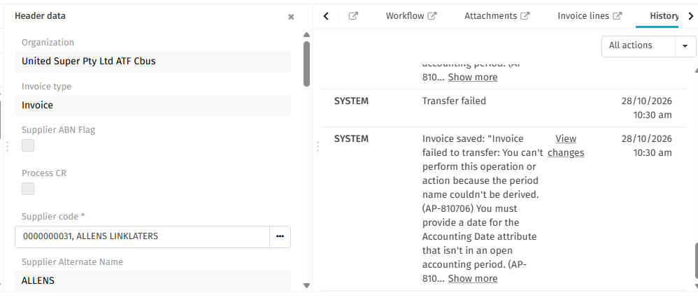

10. Post-Deployment Validation Plan
- Confirm a run with a large invoice batch posting processes every record.
- Confirm the operation log shows a run of 2. Invoice DB to JSON payload and 3.A POST Invoice to Oracle for each invoice in the batch.
- Confirm no synchronous RunOperation loop-limit message appears in the operation log.
- Confirm all invoices posted to Oracle in the batch.
- Confirm no unexpected failure emails are sent.

11. Rollback Plan
- Remove the added line from the controller script, or restore the script from the pre-deployment backup.
- Redeploy the project to Production.
- Validate the next run.
- Notify stakeholders and the client of the rollback and next steps.

12. Risks and Mitigation
Risk | Mitigation
The agent does not allow per-operation overrides, so the line has no effect. | Confirm the override setting per Section 6; check the first Production run's log.
Longer run time for large record sets, approaching the operation time-out. | Confirm typical record counts per Section 6 and monitor the first runs.
The While loop iteration limit (jitterbit.scripting.while.max_iterations, set to 500 in this script) is a separate cap and is not changed by this release. | Confirm runs stay well below 500 invoices.

13. Expected Benefits
- Invoices later in a large batch are no longer skipped after 50 synchronous RunOperation calls.
- One-line change with no business logic impact, so regression risk is minimal.

Reference
- Jitterbit: Operation Jitterbit variables, jitterbit.conf [OperationEngine], Operation troubleshooting.

